
Drones Customer Registration
Quick Start Guide
Updated January 2, 2025


Prepared For:
Defense Logistics Agency

Revision History

Revision Date | Author | Summary of Changes
12 / 19 / 2025 | Joe Pilling | Initial Draft
1 / 2 /2025 | John Carrithers | Finalized Initial Draft

Table of Contents
1. What is FedMall? How is it Accessed? 4
2. Authenticating to FedMall 4
3. Registering as a FedMall Customer 5
3.1 Before beginning 5
3.2 Establish GAM for Users 6
3.3 Steps to Register 7
4. DODAAC Validation 12
5. Managing My Account 12
6. Requesting Additional Permissions 13
6.1 Requesting MILSTRIP/FEDSTRIP Payment Method 14

What is FedMall? How is it Accessed?
FedMall is an e-commerce ordering system for Department of Defense (DoD), Federal, State, and authorized local Agencies to search for and acquire products from government reserves and commercial sources. The Drones corridor was added to the FedMall release (version FM 26.1.5). The Drones corridor in Commerce offers easy access to search for and purchase UAS and C-UAS Drones.
The new corridor provides a dedicated storefront for FedMall users to search, browse, and select from a variety of drone products. All drone items may be purchased from FedMall using a MILSTRIP Fund Code.
- As a customer, the User will access FedMall by visiting: https://www.fedmall.mil

Authenticating to FedMall
To access the FedMall Commerce Portal, a User will need to authenticate (identify) themselves with any of the following:

- Common Access Card (CAC): a credit card sized smart card issued by the DoD to uniformed service personnel, DoD civilian employees, and eligible contractors. For more information, visit: http://www.cac.mil/common-access- card/getting-your-cac/
- Personal Identify Verification (PIV) card: a credit card sized smart card issued by the U.S. Federal Government in accordance with Homeland Security Presidential Directive 12 (HSPD-12) requirements for a common identification standard for all Federal employees and contractors. For more information, visit: http://fedidcard.gov/credget.aspx
- Public Key Infrastructure (PKI) certificate: As an alternative to the physical smart card, you may also obtain a software-based X.509 certificate, which you import a file into your browser’s personal certificate store. For more information, visit: http://iase.disa.mil/pki/eca

Registering as a FedMall Customer

Before beginning
Before starting, be sure to have each of the following:
    - A valid authentication certificate, such as a CAC card, PIV card, or a soft certificate available to the web browser. (See section 2. How do I authenticate to FedMall?)
    - MILSTRIP information. (See section 6.1 Requesting MILSTRIP/FEDSTRIP Payment Method)
    - GAM established in PIEE. (See section 3.2. Establish GAM for Users)

Establish GAM for Users
What the GAM Does:
- Manages Roles: Activates, deactivates, or rejects user role requests.
- Manages Profiles: Can view and edit user profile information.
- Provides Support: Helps with password resets and certificate issues for users in their group.

Below is a step-by-step guide for establishing GAM for a user.
      - Log in to the PIEE Portal (piee.eb.mil)
      - Select the Find My Account Administrator Button
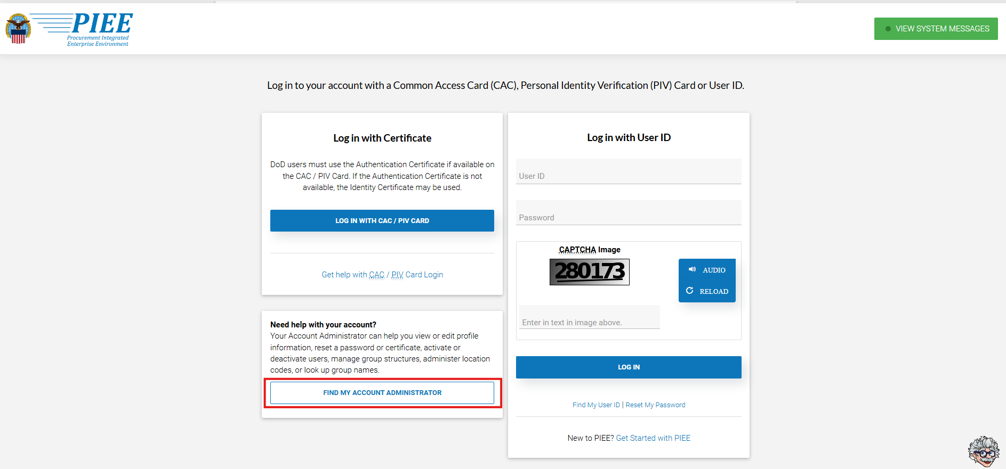
      - Enter a specific Location Code (a 6-digit DoDAAC) or the relevant Group Name (like a base or command name, e.g., USAFA, AFMC). This is a required field.
      - Select Application from the dropdown (FedMall)
      - Select Role from the dropdown to include –
        - FedMall – Vendor Supplier
        - FedMall – Federal Government Contractor Commerce
        - FedMall – FedMall Vendor Commerce
        - FedMall – FedMall PMO
        - FedMall – Federal Employee Commerce
        - FedMall – State/Local Employee Commerce
        - Cardholder (CH)
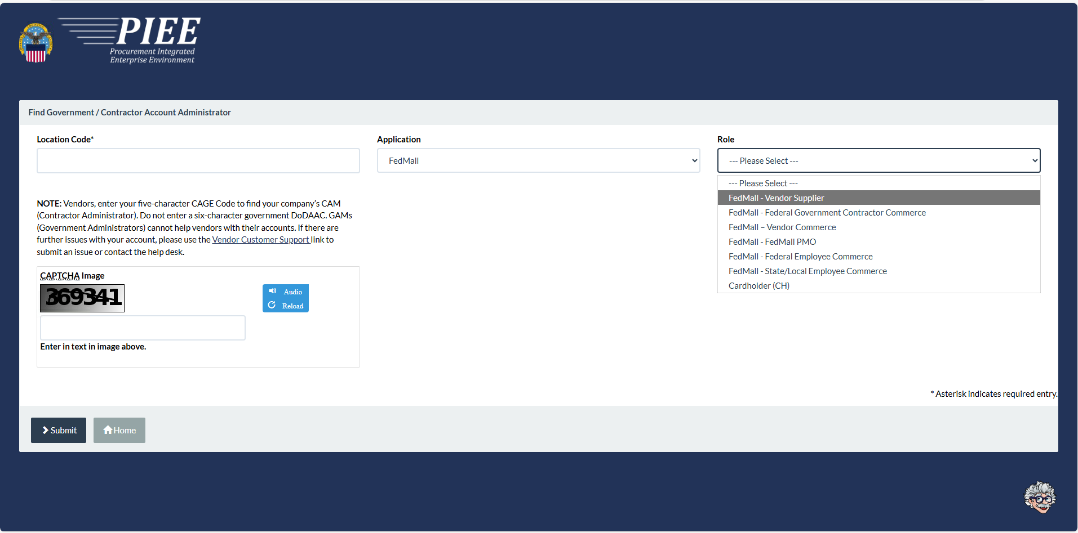

      - Click ‘Submit’ to display the GAM's information.

Steps to Register
- Visit FedMall at https://www.restricted.fedmall.mil
- The User will be brought to the Procurement Integrated Enterprise Environment application (PIEE) Landing page. From here, the User will have to register through the PIEE system. Click ‘Get Started with PIEE’ at the bottom right of the page.
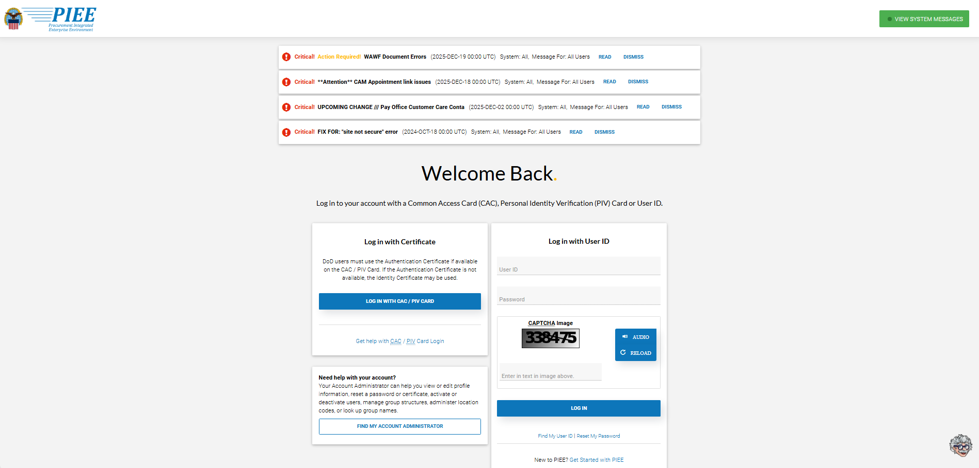
PIEE Landing Page
- The User will be brought to the PIEE Landing Page.
- Click the ‘Register’ button at the bottom of the page.
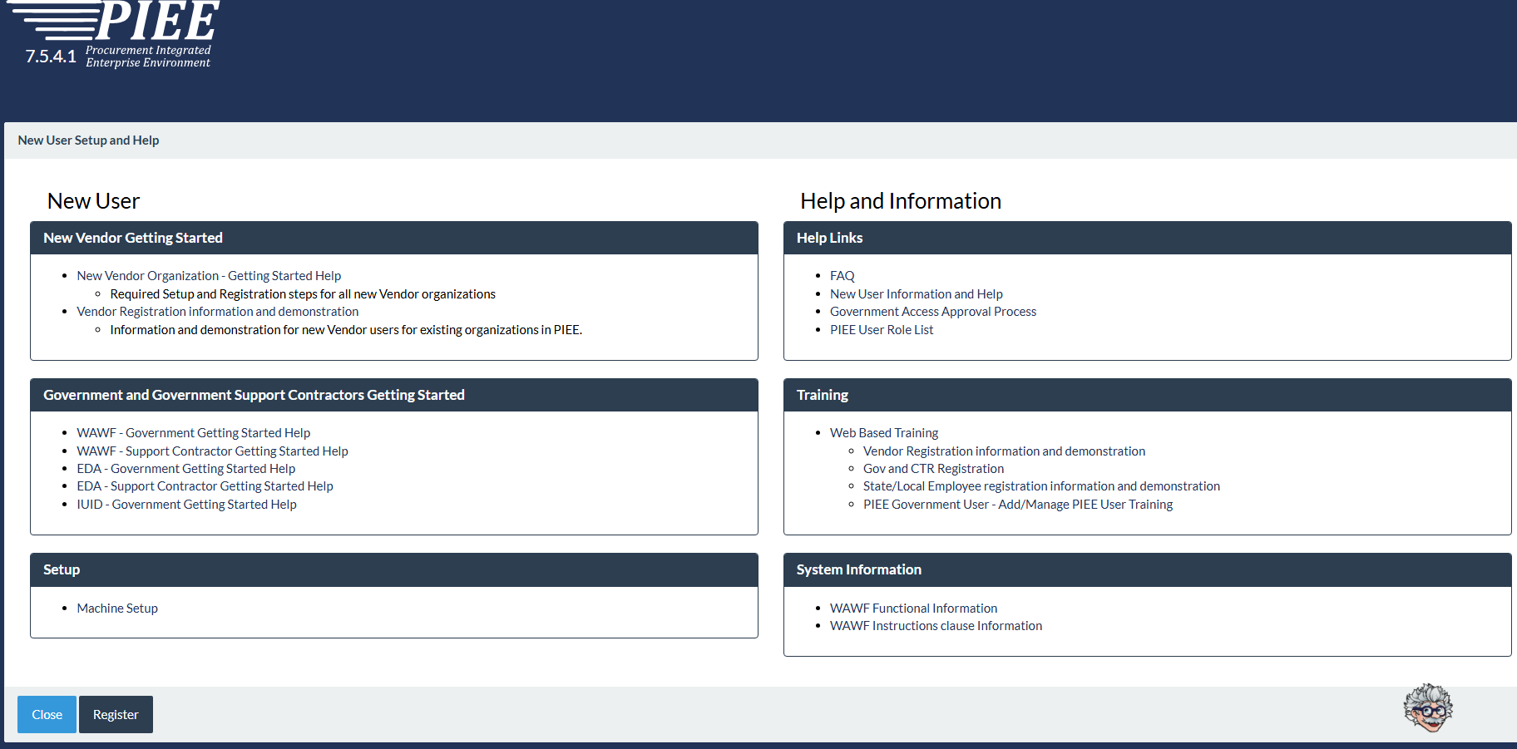
PIEE Landing Page
- Agree to the Privacy Statement and choose the Appropriate User Type. (Government – DoD, Government – Non-DoD, Government Support Contractor – Supporting DoD Organization, Government Support Contractor – Supporting Non- DoD Organization, State/ Local Employee). Subsequently, you can select your Authentication type (CAC Card or Software Certificate).
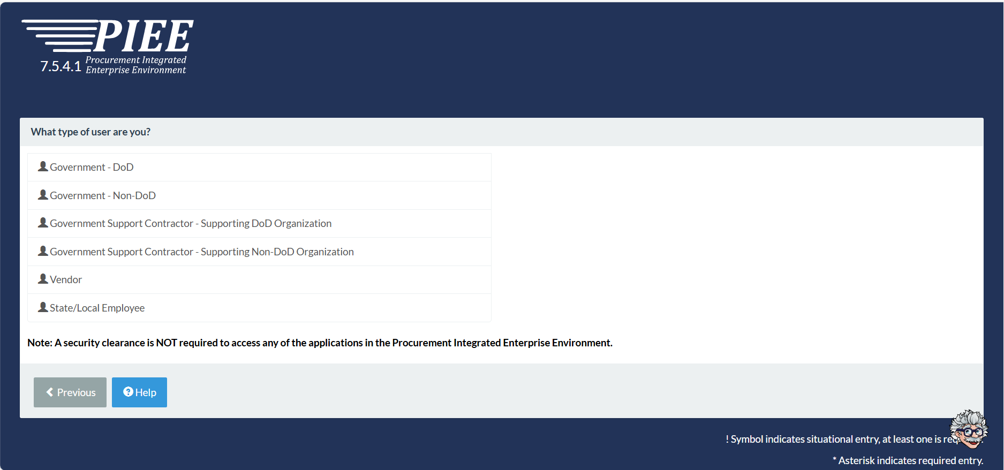
User Types
- Fill out all applicable fields on the following required forms: Profile, Roles, and Justification.
- Fill out the following field: Supervisor/ Company.
- On the Roles page, there will be a dropdown with all the modules the user can request to access. The user should select FedMall. After selecting the FedMall application, any FedMall role the user has permission to add to their profile will display.
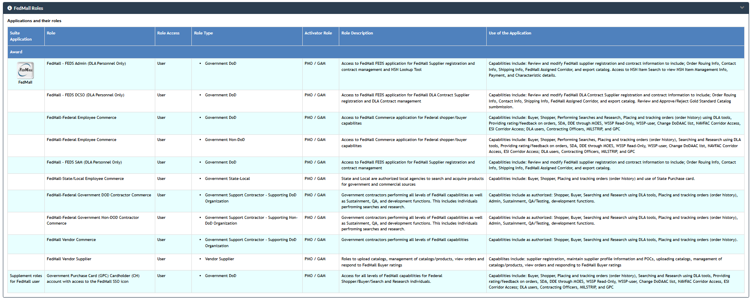FedMall Roles
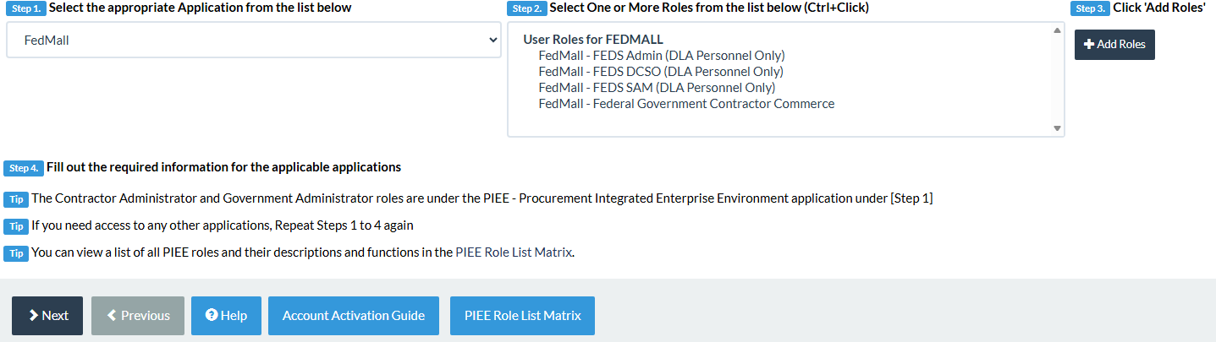Manage/Add Roles Page
- Provide Justification and review all information filled out in the registration fields. If all of the information is correct, click ‘Signature’.
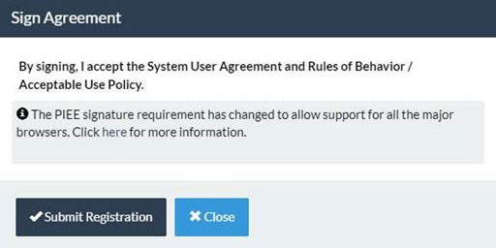
Sign Agreement
Once the agreement is signed, the user will receive a success message. The user will require GAM activation after the Registration is submitted and a supervisor has approved.

- After Registration is approved, sign in to PIEE SSO and select the FedMall Commerce icon. Clicking the FedMall Commerce Icon will bring you to the FedMall Commerce website.
- Read and accept the standard notice and consent banner.
- Complete the one-page registration form and click ‘Submit’.

Note: The following information will need to be entered For Contractors - User Name, User Type, Contractor Type, Contract Number and Current Performance Period End Date (highlighted with red boxes), all other information is pulled from the PIEE registration and is only editable through PIEE SSO.
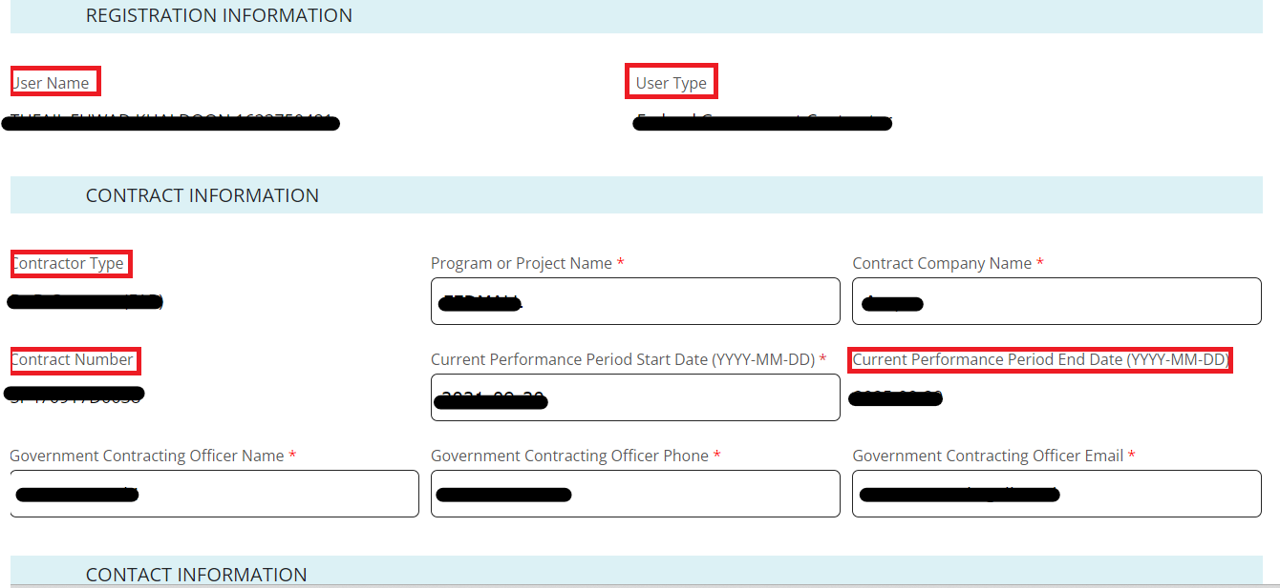
Contractor Registration Form

The following information will need to be entered for Federal Government Employees – Department, Service/Agency of Assignment, and Major Command, all other information is pulled from the PIEE registration and is only editable through PIEE SSO.
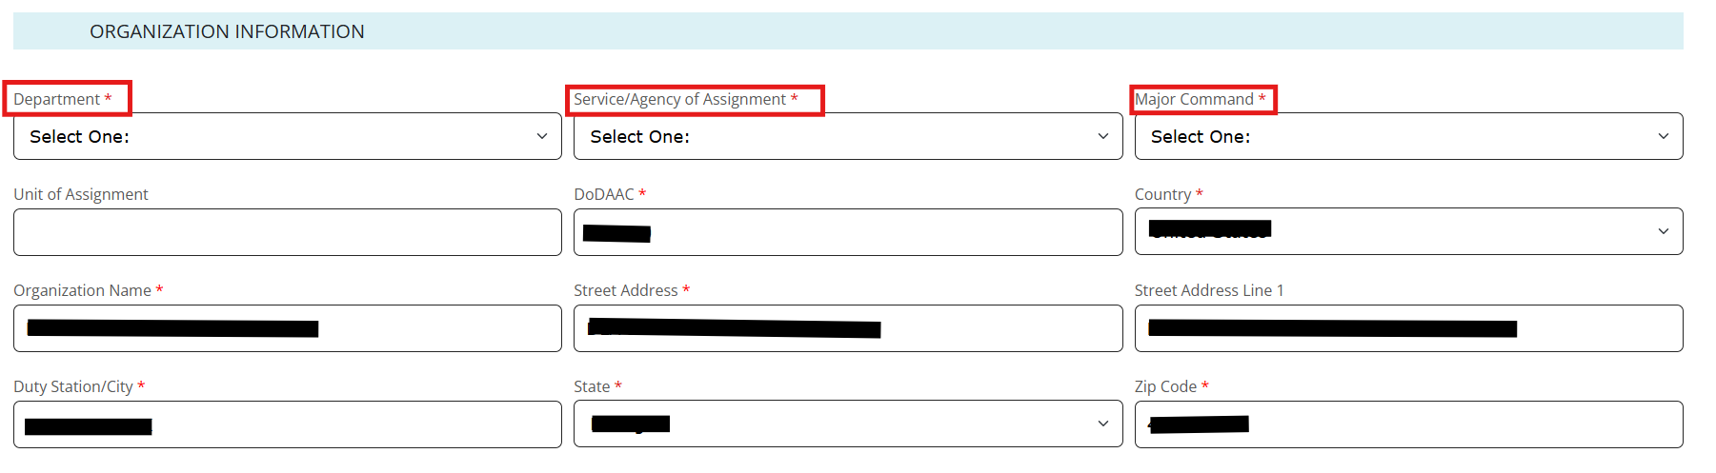
Federal Government Employee Registration Form

The following information will need to be entered for State Government Employees - Department, Service/Agency of Assignment, Major Command, State POC, POC Phone, POC Email and Justification for Use of FedMall, all other information is pulled from the PIEE registration and is only editable through PIEE SSO.
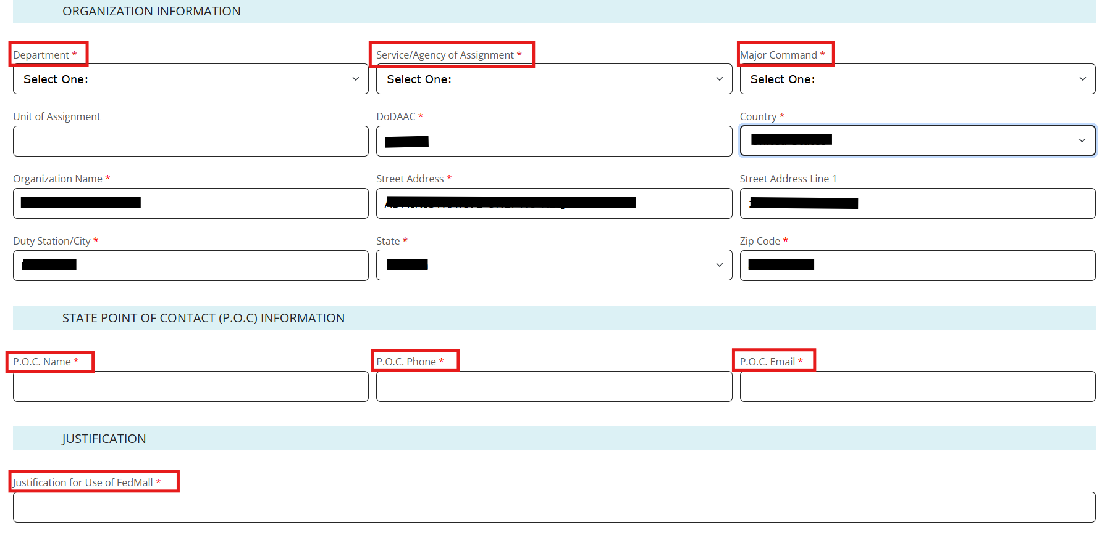
State Government Employee Registration Form

DODAAC Validation
Upon entering a DODAAC, FedMall automatically verifies the address and populates the remaining Organization Information. If DODAAC validation services are unavailable, FedMall may permit the User to continue registration. If DODAAC validation is bypassed, the User should update their account at a future date when validation services are available.
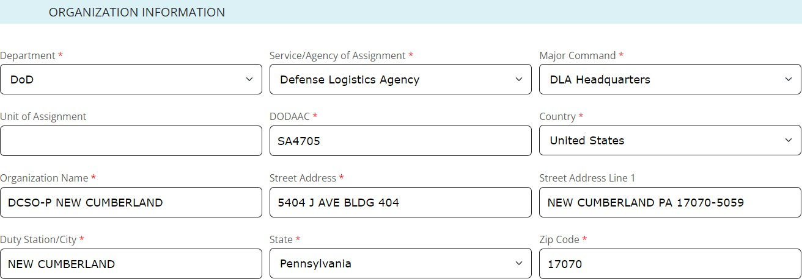
Organization Information

Managing My Account
At any time, the User can view and update their account information from the ‘My Account’ link in the header.
My Account
This will load the My Account Summary page, which contains an overview of the Personal Information page and a summary of Recent Order History.

To edit a User’s personal account information, use the ‘Personal Information’ tab under My Account and select the ‘Edit Information’ button on the My Account Profile page.

To request additional permissions (e.g., to request permission to pay via MILSTRIP), click on ‘My Permissions’ and submit the request for the applicable permission following the directions provided.

To view order history, use the ‘Order History’ link under My Account: Orders, or click the ‘View all orders’ link on the My Account Summary page (under ‘Recent Order History’).

To view requisition lists, use the ‘Frequently Purchased Items’ link under My Account: Orders.

Requesting Additional Permissions
Although the primary registration as a customer in FedMall does not require any external approvals, there are additional permissions that the User may request in order to perform specialized tasks. These are available by selecting ‘My Permissions’ from the My Account page.
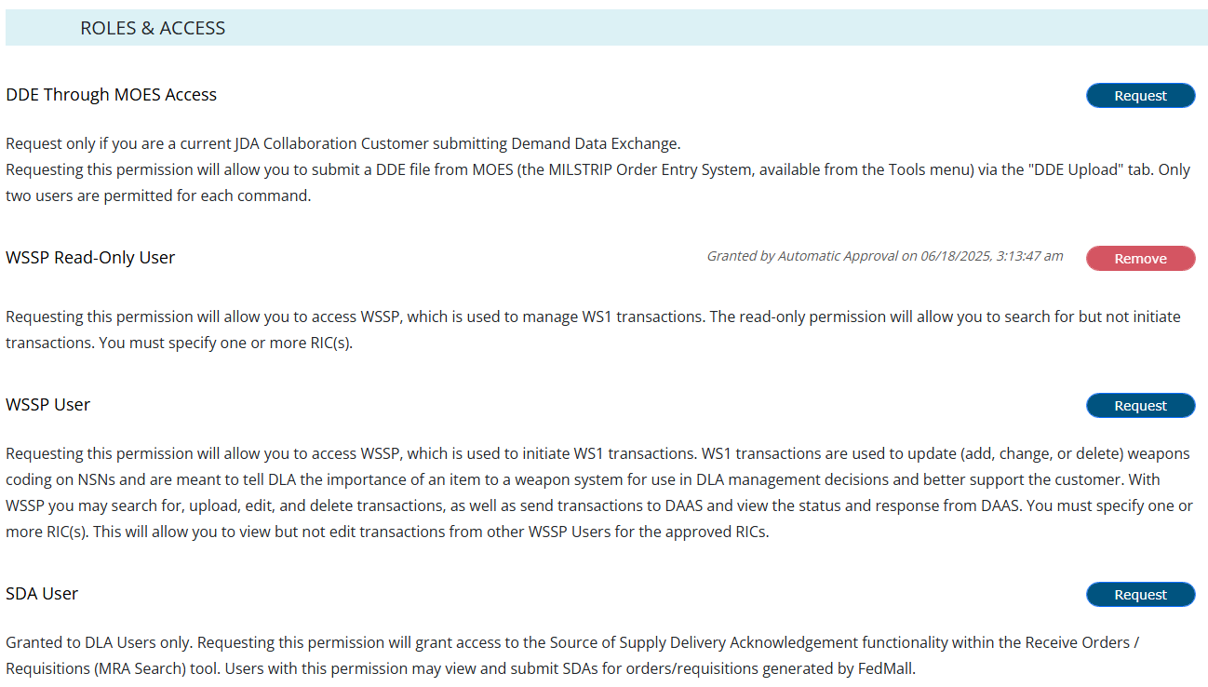
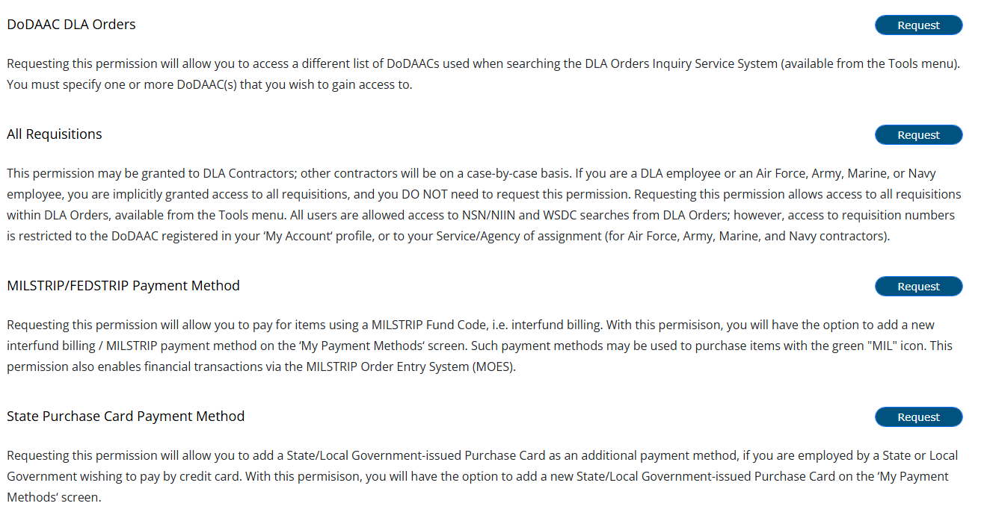
My Permissions

6.1 Requesting MILSTRIP/FEDSTRIP Payment Method
Once registered through PIEE and able to access FedMall, a User has the ability to add MILSTRIP Payment by selecting My Account from the header.
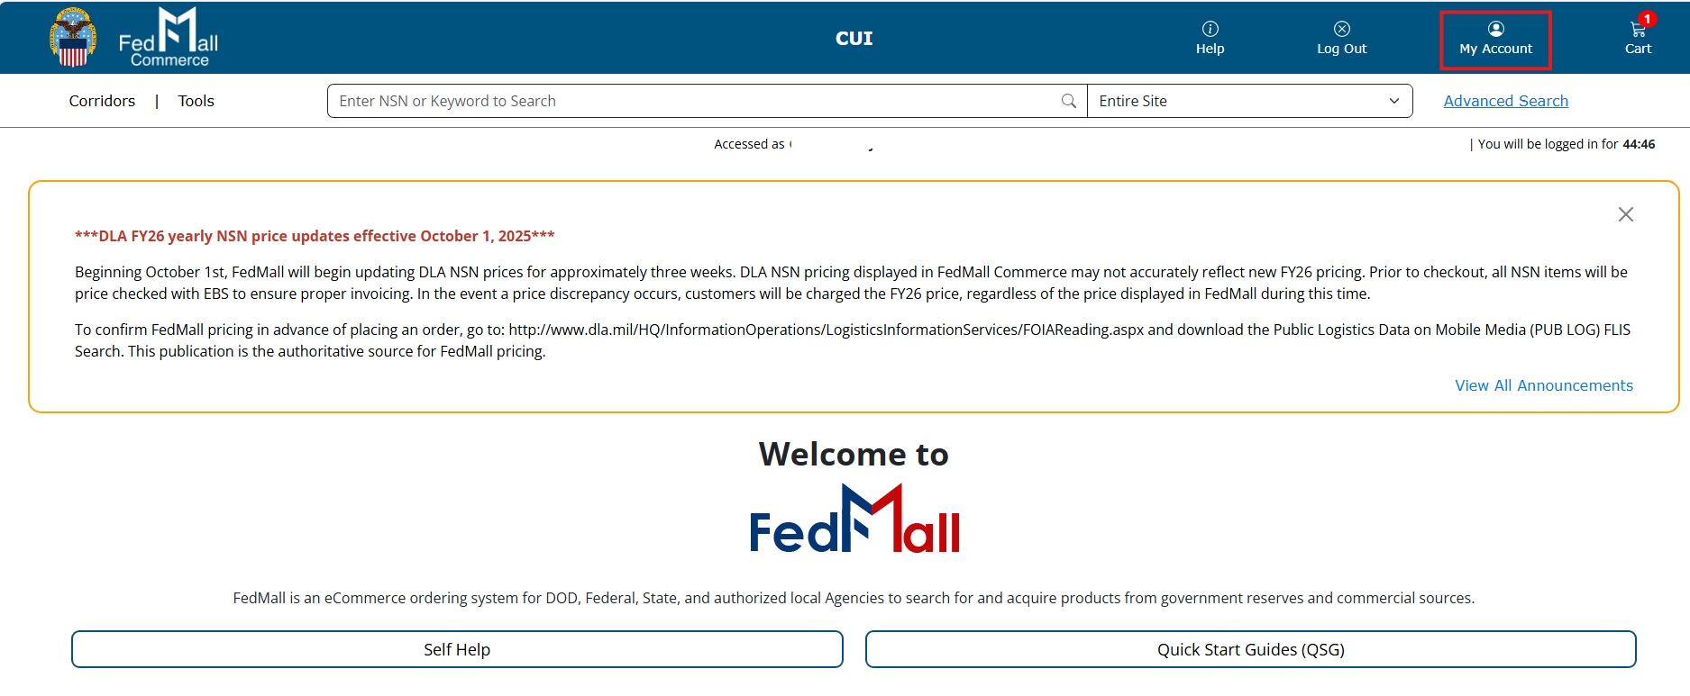FedMall Landing Page – Selecting My Account

Selecting My Permissions and Request MILSTRIP/FEDSTRIP Payment Method
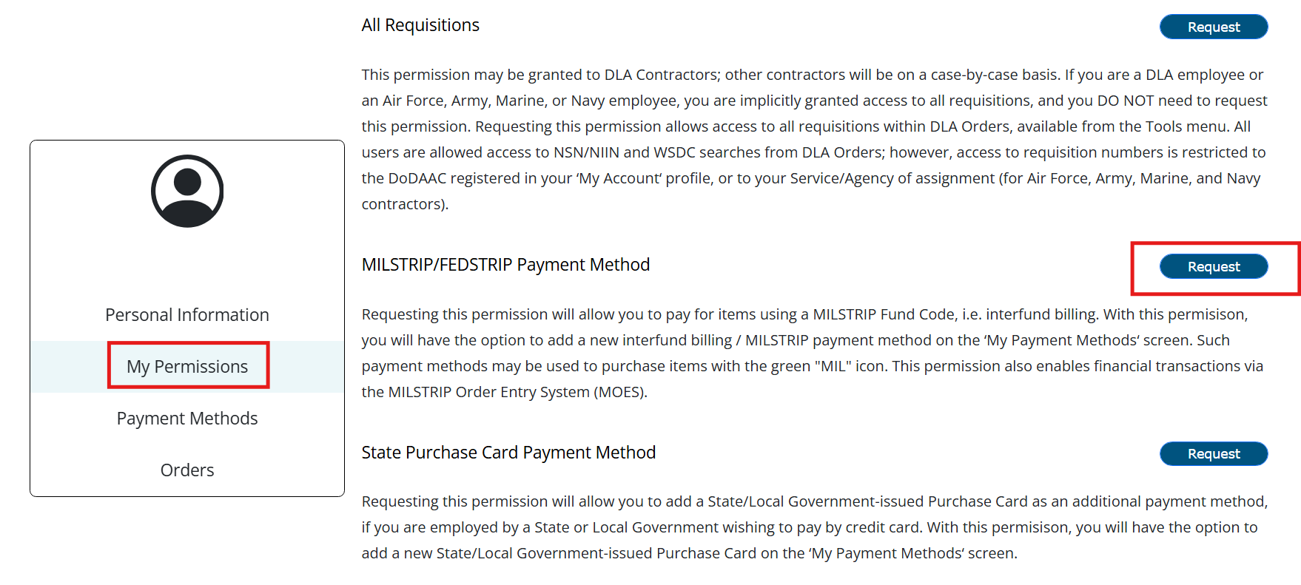
FedMall requires the MILSTRIP/ FEDSTRIP payment requestor to complete/enter the following information – FUND Code, Supply Officer’s Name, Supply Office’s Phone, Supply Officer’s Email and Supplemental Address, acknowledge the statements below by selecting the check box, and submit the form using the Request button in FedMall.
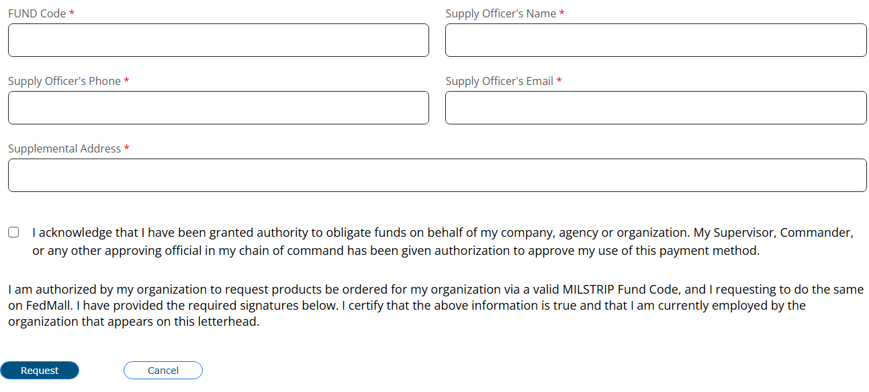
- ‘I acknowledge that I have been granted authority to obligate funds on behalf of my company, agency or organization. My Supervisor, Commander or any other approving official in my chain of command has been given authorization to approve my use of this payment method’.
- ‘I am authorized by my organization to request products be ordered for my organization via a valid MILSTRIP Fund Code, and I am requesting to do the same on FedMall. I have provided the required signatures below. I certify that the above information is true and that I am currently employed by the organization that appears on this letterhead.’

The User is then granted MILSTRIP payment method.
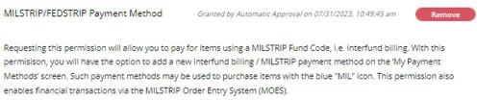
MILSTRIP Payment Method Approved

